|  |  |  |  |  |
| --- | --- | --- | --- | --- |
| C:\Users\David\Dropbox\rossmoyne.png  **Reading Time**: An initial **2 minutes** to view **BOTH** sections | **MATHEMATICS METHODS : UNITS 3 & 4, 2022**  Test 1 – (10%) 3.1.7, 3.1.8, 3.1.10 to 3.1.16, 3.2.1 to 3.2.3, 3.2.6, 3.2.7 | | |  |
| **Time Allowed**  20 minutes | | **First Name Surname** | **Marks**  20 marks | |

**Circle your Teacher’s Name:** Mrs Alvaro Mrs Bestall Mrs Fraser-Jones Mr Gibbon Mrs Greenaway Mr Koulianos Mr Luzuk Mrs Murray Mr Tanday

|  |  |
| --- | --- |
| **Assessment Conditions: *(N.B. Sufficient working out must be shown to gain full marks)***   |  | | --- | | * Calculators: Not Allowed * Formula Sheet: Provided * Notes: Not Allowed | |

**PART A – CALCULATOR FREE**

**QUESTION 1 (6 marks)**

1. Differentiate  (do not simplify beyond positive indices). (2 marks)
2. Let 
   * 1. Evaluate . (3 marks)
     2. What does your result in part (i) represent? (1 mark)

**QUESTION 2 (4 marks)**

The radius of a sphere increases from 10cm to 10.1cm. Find the approximate increase in surface area that this causes.

**QUESTION 3 (5 marks)**

1. Find  (2 marks)
2. Find  (2 marks)
3. Find  (1 mark)

**QUESTION 4 (5 marks)**

Consider the function , defined for . The graph of  is shown below. Point B is a local maximum with *x*-coordinate *b*, point D is an inflection point with *x*-coordinate *d*, and point F is a local minimum with *x*-coordinate *f*.

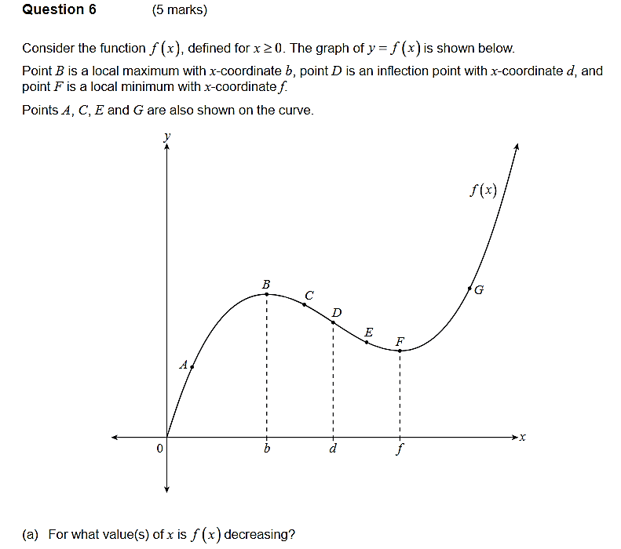

1. Identify the point(s) (i.e. A, B, C, D, E, F or G) with the following properties:
   * 1.  and . (1 mark)
     2.  and . (1 mark)
   1. On the axes below sketch the graph of . (3 marks)

